How Do I Obtain CPE credit for the OSHP 82nd Annual Meeting using LecturePanda?
First, from the announcement on our website, click the register button or scan the QR code with your smartphone to move on to the next step. | 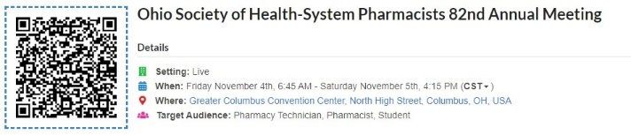
Next, select the appropriate registration type from the list. | 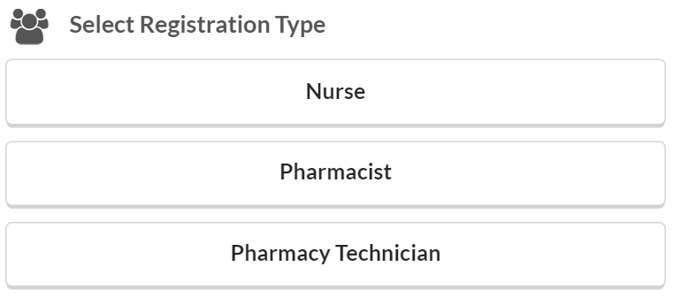
Finally, fill in the registration form with the required information and click “Submit Registration.” | 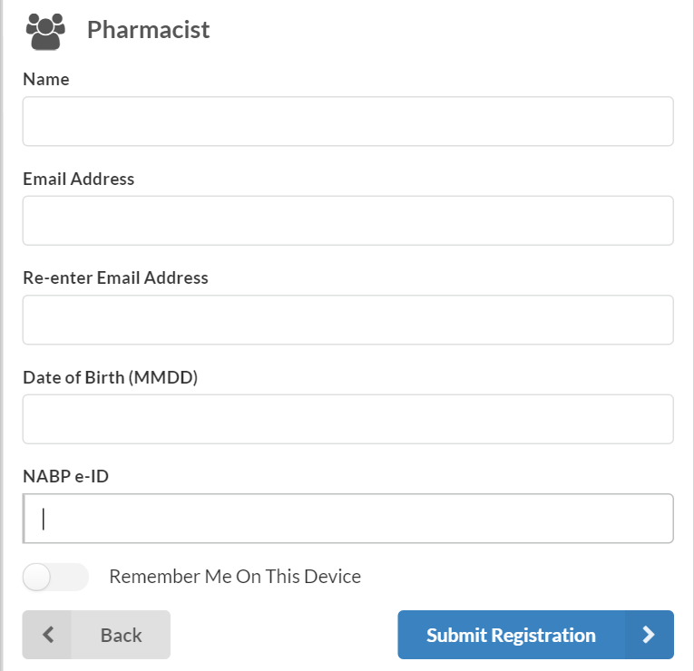
Now you’re registered for the activity!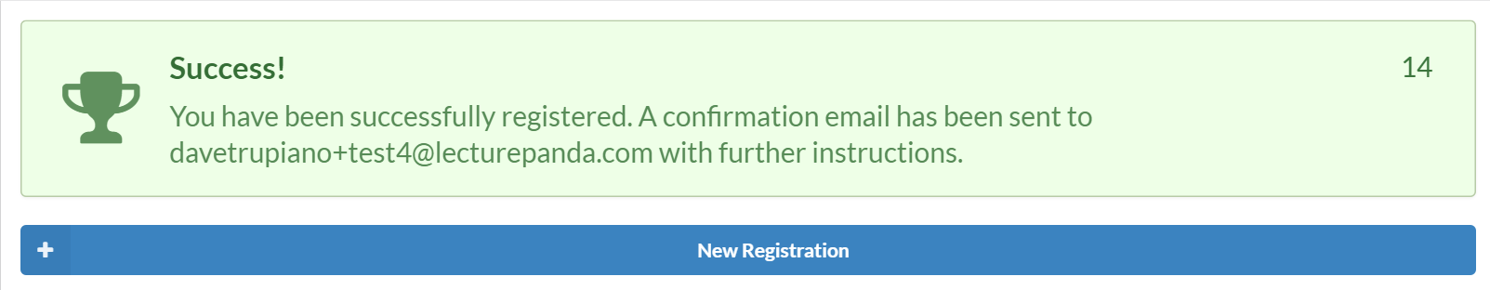

How Do I Complete the Requirements and Receive Credit?
After you register, you will receive an email with a link to complete the credit requirements. Click the link to continue.
Next, you will be given access to download any learning materials for the activity. Click "Next" on the bottom right to continue. | 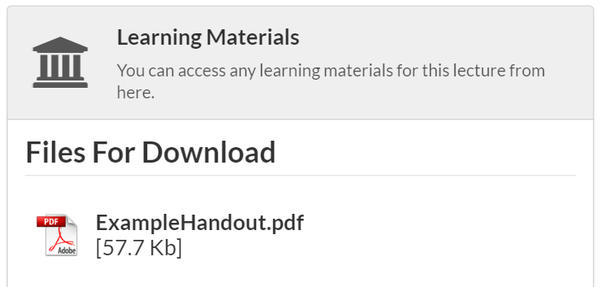
Next, you will be asked to confirm your registration information. Review your information, make any necessary changes and click "Next" on the bottom right to continue. | 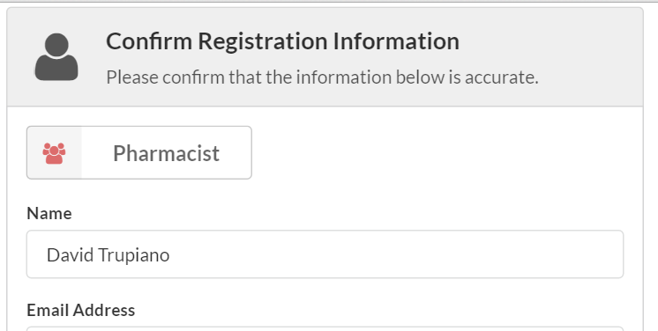
Next, select the credits that you would like to claim from the list. Click “Next” on the bottom right to continue. | 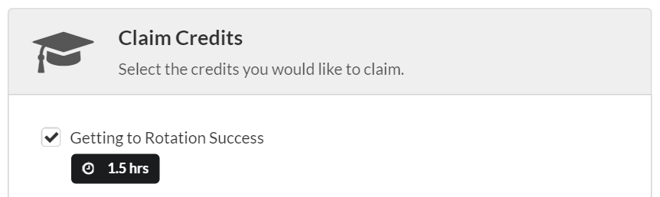
Finally, complete any listed evaluations or quizzes. Once completed, click “Submit” or “Next” on the bottom right to continue. | 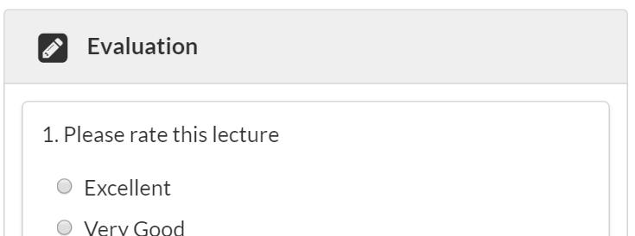
The status of your credits will be shown and you may optionally download a PDF certificate. You are now done and your credits will appear in CPE monitor within 24 hours. | 